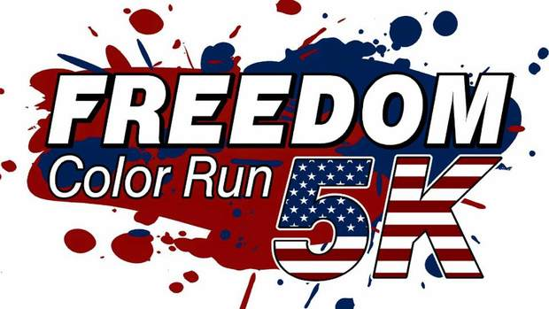

WHEN: Saturday June 25, 2016 Registration starts at 7:15AM,
Race starts at 8:00AM

WHERE: Race will begin and end at Patterson City Hall
1314 Main Street Patterson, LA 70392

Cost: $25 early registration fee, $30 after May 20
*Price includes race day t-shirt if turned in by May 20 (SHIRT NOT GUARANTEED AFTER MAY 20)

ALL PROCEEDS go to the Patterson Economic Development Sustainability Committee
CONTACT: RYAN AUCOIN 985-519-1928 OR 985-395-5205
FORMS CAN BE MAILED TO: PO BOX 367 PATTERSON, LA 70392
FORMS CAN BE EMAILED: ryan.aucoin@cityofpattersonla.gov

REGISTRATION:

NAME:_________________________________________________________ PHONE:______________________________

ADDRESS:_________________________________________________CITY/STATE/ZIP:________________________

EMAIL:____________________________________________________ AGE/GENDER:____________________________

SHIRT SIZE (CIRCLE ONE) ADULT: S M L XL XXL

WAIVER (MUST SIGN WAIVER TO PARTICIPATE)
RELEASE FORM: UPON ACCEPTANCE OF THIS ENTRY FORM, I WAIVE ALL CLAIMS FOR MYSELF AND MY HEIRS AGAINST THE FREEDOM COLOR RUN, PEDSCO, CITY OF PATTERSON, RACE OFFICIALS, VOLUNTEERS AND SPONSORS OF THE RUN FOR INJURY OR ILLNESS FROM DIRECT OR INDIRECT PARTICIPATION. I ALSO GRANT PERMISSION TO USE ANY PHOTOGRAPHS OR OTHER PROMOTIONAL RECORD(S) OF THIS EVENT FOR ANY LEGITIMATE REASON. I FURTHER UNDERSTAND THAT THERE ARE NO REFUNDS, IF FOR ANY REASON, I AM UNABLE TO RUN THIS RACE OR THIS RACE IS CANCELLED DUE TO UNFORSEEN CIRCUMSTANCE.

______________________________________________ _______________________________________________
SIGNATURE DATE SIGNATURE OF PARENT OR GUARDIAN (IF UNDER 18)

